Standard Email Signatures Policy
Policy Name: Standard Email Signature Policy
Effective Date: January 1, 2011

Purpose
This documents the required email signatures on all emails sent from AMS-PAR to any email address. This policy will be in effect January 1, 2011.

Rationale
The email signatures on all external correspondence should have a standard style for all email sent. This standardization helps strengthen the brand of AMS-PAR and improves the professional appearance of the organization.

Omitted
You will notice that we have omitted the inclusion of the logo from the email signature. This is a courtesy to recipients not having to receive emails larger than necessary and to eliminate the notification, in most email clients, that there is an attachment to the email message. The goal of this is to improve the ability to search for an email with an attachment and to not identify the logo as an attachment.

Requirements
All email signatures should appear as follows:
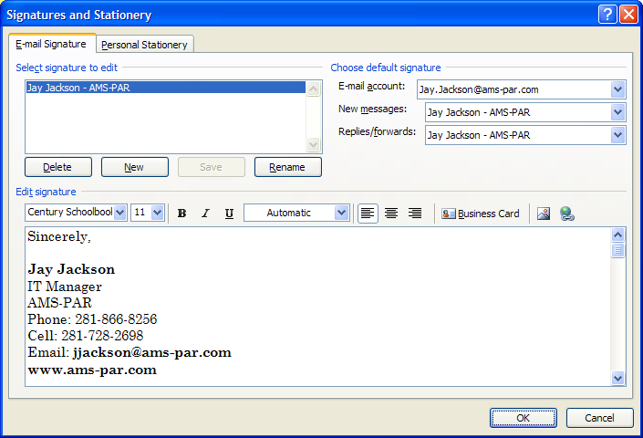
All fonts must be in Century Schoolbook

Your Name
Your Title
AMS-PAR
Office Phone: 281-866-
Cell: [optional not bold]
Email: Email Address Bold
www.ams-par.com

Nothing else should appear after the web site including graphics.

When configuring the signature in Outlook you must configure the signature to be using on all “New messages”. Adding the signature to replies and forwards is optional.

Signature Example

Sincerely,

Jay Jackson
IT Manager
AMS-PAR
Phone: 281-866-8256
Cell: 281-728-2698
Email: jjackson@ams-par.com
www.ams-par.com

Changes to Policy
Changes to this policy may be accepted for special cases, promotions or other reasonable cases. Altering your signature’s format to any format other than what is indicated here is violation to this policy. Any changes to the Signature Standard must be approved prior to its use.

Implementation
Application of the signatures to email software should be simple and is user managed. There should be no need for administrative rights on the workstations to perform any signature changes.

How to Change the Signatures
Reference the steps below to access the email signature option settings.

Outlook 2010
Click on the File Menu Options Mail menu on the left side Signatures Button on the Right side

Outlook 2007
Tools Menu Options Mail Format Tab Signatures.. Button

Click on New or Edit an existing signature.

Outlook Web Access
Open Webmail.

Select Options Menu from the bottom of the left pane.

Click on the Edit Signature Button

Create Signature based on the sample provided.

Be sure to click on the option to automatically apply the signature.

Other Email Software
Other email software clients will support the signatures but they are outside the scope of this document and are not supported.

